**Semester Two**

**Insert School Logo**

**Examination, 2024**

**Question/Answer Booklet**

**HUMAN BIOLOGY**

**UNIT 1 & 2**

Name: Marking Guide

Teacher: ______________________________________________________

**Time allowed for this paper**

Reading time before commencing work: ten minutes

Working time for the paper: three hours

**Materials required/recommended for this paper**

***To be provided by the supervisor***

This Question/Answer Booklet

Multiple-choice Answer Sheet

***To be provided by the candidate***

Standard items: pens (blue/black preferred), pencils (including coloured), sharpener, correction fluid/tape, eraser, ruler, highlighters

Special items: up to three calculators, which do not have the capacity to create or store programmes or text, are permitted in this ATAR course examination

**Important note to candidates**

No other items may be taken into the examination room. It is **your** responsibility to ensure that you do not have any unauthorised material. If you have any unauthorised material with you, hand it to the supervisor **before** reading any further.

**Structure of this paper**

|  |  |  |  |  |  |
| --- | --- | --- | --- | --- | --- |
| Section | Number of questions available | Number of questions to be answered | Suggested working time (minutes) | Marks available | Percentage of examination |
| Section One Multiple-choice | 25 | 25 | 30 | 25 | 30 |
| Section Two Short answer | 7 | 7 | 80 | 90 | 50 |
| Section Three Extended answer  Unit 1 | 2 | 1 | 40 | 15 | 10 |
| Unit 2 | 2 | 1 | 20 | 10 |
|  |  |  |  | **Total** | 100 |

**Instructions to candidates**

1. The rules for the conduct of the Western Australian examinations are detailed in the *Year 12 Information Handbook 2023: Part II Examinations*. Sitting this examination implies that you agree to abide by these rules.

2. Write your answers in this Question/Answer booklet preferably using a blue/black pen. Do not use erasable or gel pens.

3. Answer the questions according to the following instructions.

Section One: Answer all questions on the separate Multiple-choice answer sheet provided. For each question, shade the box to indicate your answer. Use only a blue or black pen to shade the boxes. Do not use erasable or gel pens. If you make a mistake, place a cross through that square, then shade your new answer. Do not erase or use correction fluid/tape. Marks will not be deducted for incorrect answers. No marks will be given if more than one answer is completed for any question.

Section Two: Write your answers in this Question/Answer booklet. Wherever possible, confine your answers to the line spaces provided.

Section Three: Consists of two parts each with two questions. You must answer one question from each part. Tick the box next to the question you are answering. Write your answers in this Question/Answer booklet

4. You must be careful to confine your answers to the specific questions asked and to follow any instructions that are specific to a particular question.

5. Supplementary pages for planning/continuing your answers to questions are provided at the end of this Question/Answer booklet. If you use these pages to continue an answer, indicate at the original answer where the answer is continued, i.e. give the page number.

**Section One: Multiple-choice 30% (30 Marks)**

This section has **30** questions. Answer **all** questions on the separate Multiple-choice answer sheet provided. For each question, shade the box to indicate your answer. Use only a blue or black pen to shade the boxes. Do not use erasable of gel pens. If you make a mistake, place a cross through that square, then shade your new answer. Do not erase or use correction fluid/tape. Marks will not be deducted for incorrect answers. No marks will be given if more than one answer is completed for any question.

Suggested working time: 40 minutes.

1. The process whereby chromosomes separate during the first meiotic division, leading to variation in alleles in the gametes, is known as

(a) random fertilsation.

(b) non-disjunction.

(c) independent assortment.

(d) crossing over.

2. Andrea, who has the autosomal recessive condition known as cystic fibrosis (CF), marries a man whom has no history of CF in his family. What is the most likely probability, as a percentage, of their children having CF?

(a) 0%

(b) 25%

(c) 75%

(d) 100%

3. Which of the following is not a structural feature of the alveoli that makes them suited to gas exchange?

(a) They have a low surface area.

(b) They are surrounded by blood vessels.

(c) They have a very thin wall.

(d) They are covered by a thin layer of moisture.

4.. Which of the following contraception methods cannot help prevent transmission of sexually transmitted infections?

(a) chemical spermicides

(b) condoms

(c) abstinence

(d) female condoms

Questions 5 to 7 refer to the following diagram showing the process of meiosis.

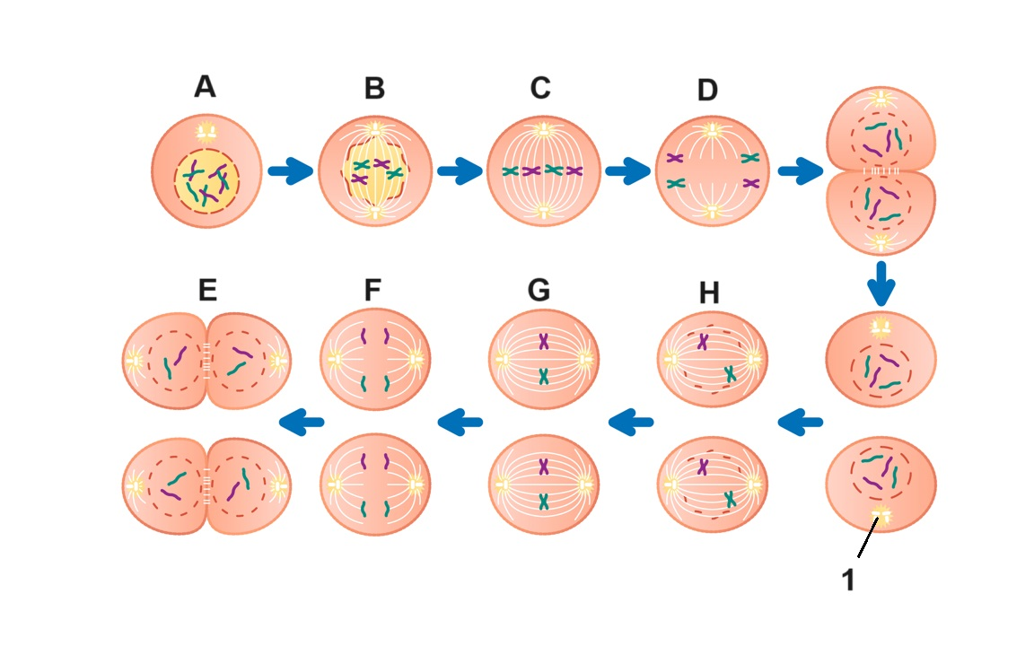

5. During which of the phases labelled on the diagram does crossing over occur?

(a) A

(b) B

(c) C

(d) D

6. The organelles labelled with the number 1 are known as

(a) centromeres.

(b) chromatin.

(c) microtubules.

(d) centrioles.

7. During oogenesis, in which phase labelled on the diagram above does meiosis stop at, after ovulation occurs?

(a) E

(b) F

(c) G

(d) H

8. Which of the following structures is not formed by the mesoderm during embryonic development?

(a) cartilage

(b) lymphoid tissue

(c) hair

(d) muscles

Question 9 and 10 refer to the following pedigree chart showing the inheritance of alleles that results in the production of the antigens from the ABO blood grouping system. The shaded individuals have type O blood.

**Note:** this pedigree does not include information about inheritance of the Rhesus factor.

9. Which of the following is the correct annotation for the genotype of the shaded individuals?

(a) ii

(b) oo

(c) IoIo

(d) II

10. If the female in generation I has type A, and the male has type B blood, what type of blood do their children **without** type O have?

(a) type A

(b) type B

(c) type AB

(d) not enough information provided to determine blood type

11. Which of the following terms refers to how correct, or true, the results of an investigation are?

(a) reliability

(b) validity

(c) accuracy

(d) precision

12. Before gas exchange occurs in the alveoli,

(a) the blood in the capillaries has a high concentration of oxygen, but a low concentration of carbon dioxide.

(b) the blood in the capillaries has a low concentration of oxygen, and a low concentration of carbon dioxide.

(c) the blood in the capillaries has a high concentration of oxygen, and a high concentration of carbon dioxide.

(d) the blood in the capillaries has a low concentration of oxygen, but a high concentration of carbon dioxide.

Question 13 and 14 refer to the diagram below of the cell membrane.

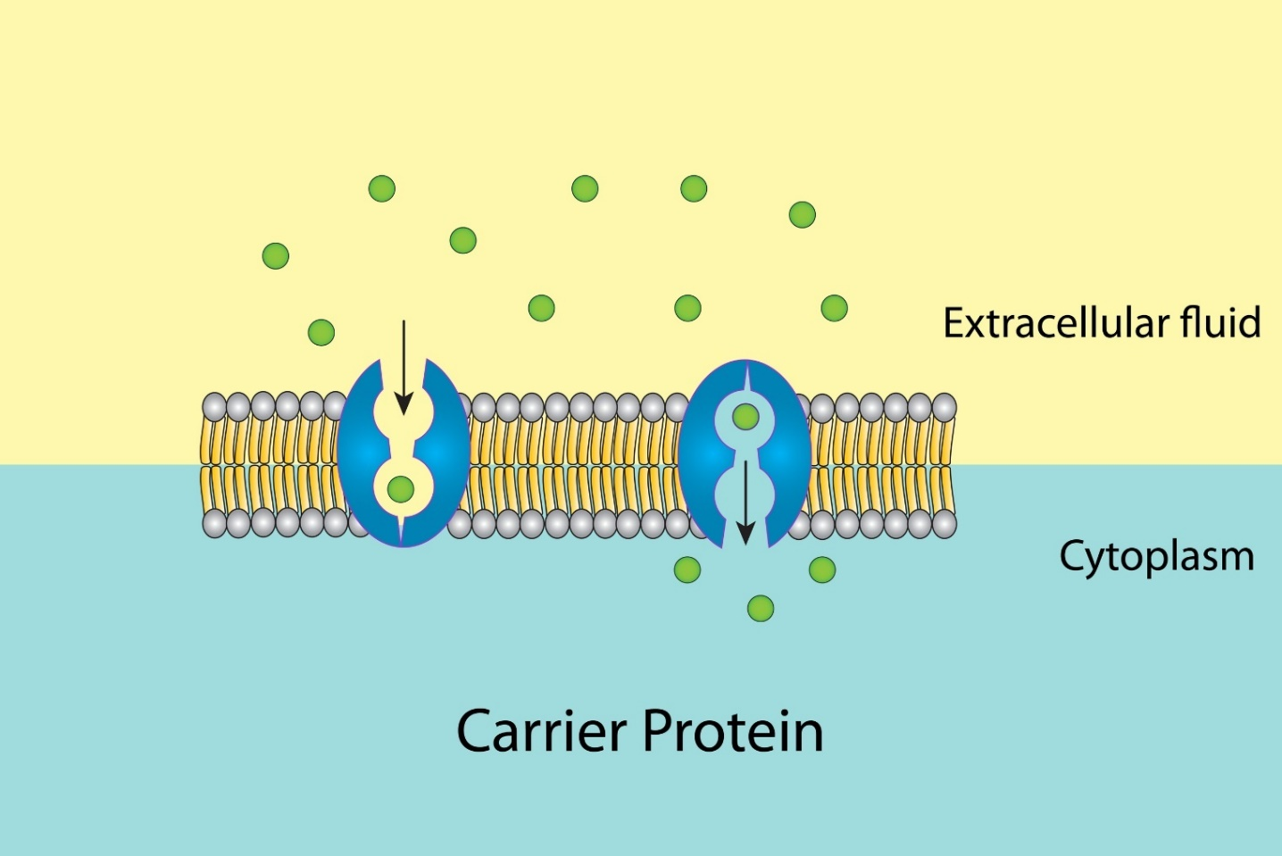

13. The correct name for the protein found in the diagram is a

(a) carrier protein.

(b) channel protein.

(c) receptor protein.

(d) diffusion protein.

14. Which of the following best describes the transport across the membrane shown in the diagram?

(a) passive, against the concentration gradient

(b) active, against the concentration gradient

(c) passive, with the concentration gradient

(d) active, with the concentration gradient

15. Fertilisation occurs in the

(a) ovary.

(b) fallopian tube.

(c) uterus.

(d) vagina.

Question 16 and 17 refer to the following diagram illustrating the structure of a sarcomere.

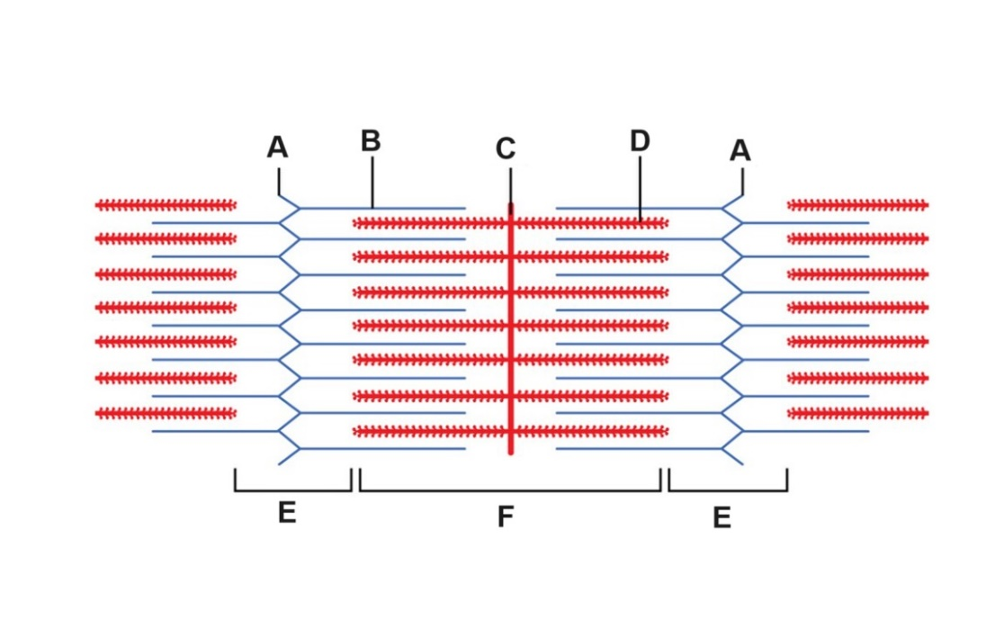

16. The part labelled B is known as

(a) myosin.

(b) actin.

(c) the A band.

(d) the I band.

17. During muscle contraction

(a) Structure D decreases in length.

(b) The distance represented by E shortens.

(c) The distance represented by F lengthens.

(d) Structure A increases in length.

18. Which of the following is the correct name given to the biotechnological technique that can allow scientists to produce a DNA profile?

(a) polymerase chain reaction

(b) genetic engineering

(c) gel electrophoresis

(d) genetic probing

19. The type of cartilage found in the vertebral discs is known as

(a) hyaline cartilage.

(b) articular cartilage.

(c) elastic cartilage.

(d) fibrocartilage.

Questions 20 to 21 refer to the following diagram showing muscles and bones at the elbow joint.

20. The type of movement, indicated by the letter A is known as

(a) flexion.

(b) extension.

(c) adduction.

(d) abduction.

21. The muscle group F during movement A is referred as the

(a) antagonists.

(b) agonists.

(c) synergists.

(d) biceps.

22. The structure labelled G is known as the

(a) insertion.

(b) tendon.

(c) cartilage.

(d) ligament.

23. Which of the following descriptions correctly describes acetylation and its role as part of the epigenome?

(a) Acetylation occurs when an acetyl group attaches to a DNA molecule, enhancing gene expression.

(b) Acetylation occurs when an acetyl group attaches to a histone protein, inhibiting gene expression.

(c) Acetylation occurs when an acetyl group attaches to a DNA molecule, inhibiting gene expression.

(d) Acetylation occurs when an acetyl group attaches to a histone protein, enhancing

gene expression.

24. Tissue containing branched, striated cells, with intercalated discs is most correctly referred to as

(a) muscular tissue.

(b) smooth muscle.

(c) cardiac muscle.

(d) skeletal muscle.

25. The ductus venosus allows for blood to bypass which of the following organs during foetal circulation?

(a) lungs

(b) kidneys

(c) stomach

**End of Section One**

**Section Two: Short answer 50% (90 Marks)**

This section has **seven** questions. Answer **all** questions. Write your answers in the spaces provided.

Supplementary pages for planning/continuing your answers to questions are provided at the end of this Question/Answer booklet. If you use these pages to continue an answer, indicate at the original answer where the answer is continued, i.e. give the page number.

Suggested working time: 80 minutes.

**Question 26 (16 marks)**

A combination of chemotherapy and radiotherapy is being recommended for some forms of small tumour lung cancer. One randomised clinical trial tested the effect of this combined treatment on lung cancer sufferers.

This trial involved splitting a group of 200 people with lung cancer, at random, into a control group and an experimental group. Those in the experimental group were given the treatment once-daily over the space of 6 months, while those in the control group received a placebo. The patients were given a CT scan monthly to determine the percentage change in the size of the tumour.

The table below show the reduction in the size of tumours, as a percentage, in the two groups over time.

|  |  |  |  |  |  |  |
| --- | --- | --- | --- | --- | --- | --- |
|  | Average percentage (%) of tumour remaining each month | | | | | |
| Month 1 | Month 2 | Month 3 | Month 4 | Month 5 | Month 6 |
| Experimental Group | 90 | 82 | 70 | 63 | 51 | 38 |
| Control Group | 97 | 94 | 92 | 95 | 88 | 90 |

(a) Explain the purpose of the control group in this investigation. (2 marks)

|  |  |
| --- | --- |
| **Description** | **Marks** |
| To act as a comparison | 1 |
| To see the effect of the chemo/radiotherapy on the experimental group | 1 |
| **Total** | **2** |

(b) Identify **two** controlled variables in this investigation. (2 marks)

|  |  |
| --- | --- |
| **Description** | **Marks** |
| Any two from the following | |
| * Same amount of treatment/daily treatment * Same time for CT scan/monthly CT scan * Same no. of people in control and experimental group * Other relevant answer | 1-2 |
| **Total** | **2** |

(c) Suggest a possible hypothesis for this investigation. (2 marks)

|  |  |
| --- | --- |
| **Description** | **Marks** |
| Any clear statement linking the independent and dependent variable, for example | |
| The combination of radiation and chemotherapy will reduce the size of tumours in lung cancer (compared to placebo) | 1-2 |
| **Total** | **2** |

(d) Graph the results of the clinical trial on the grid below. (5 marks)

|  |  |
| --- | --- |
| **Description** | **Marks** |
| Appropriately titled | 1 |
| Labels and units on axes | 1 |
| Appropriate scale (could include a broken *y*-axis, not shown in the example below) | 1 |
| Correctly plotted line graph against time | 1 |
| Key/legend included | 1 |
|  | |
| **Total** | **5** |

(e) Outline a conclusion based on the data in the graph. (2 marks)

|  |  |
| --- | --- |
| **Description** | **Marks** |
| The combination of radiotherapy and chemotherapy caused a reduction in the size of the tumour (compared to placebo) | 1 |
| As seen in the graph through the downwards trend in the line representing radiotherapy and chemotherapy combination treatment (or similar, referring to graph) | 1 |
| **Total** | **2** |

**Question 31** (continued)

(f) Define what cancer is and explain the impact that a tumour can have on the functioning of normal body cells/tissues. (3 marks)

|  |  |
| --- | --- |
| **Description** | **Marks** |
| Where cells divide uncontrollably to form a tumour | 1 |
| Which is malignant/has the potential to spread to other body parts | 1 |
| These cells use up nutrients/take up the space occupied by non-cancerous cells | 1 |
| **Total** | **3** |

**This page has been left blank intentionally**

**Question 27 (16 marks)**

The diagram below shows the structure of the nephron in the human kidneys.

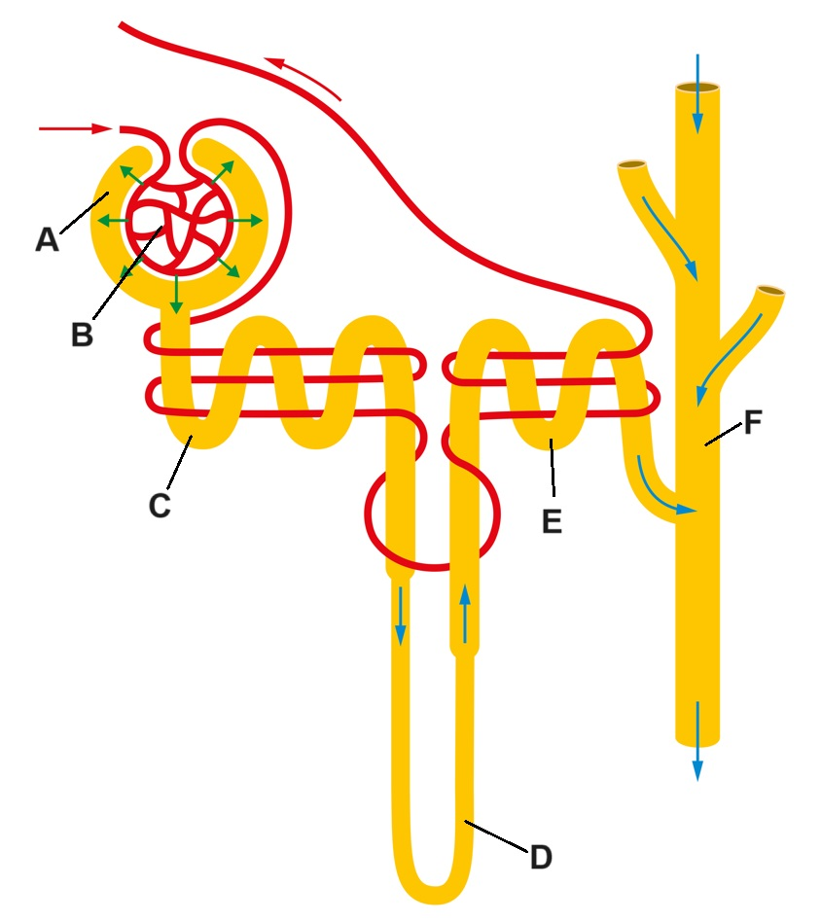

(a) Complete the table below by identifying the parts labelled in the diagram. (3 marks)

|  |  |
| --- | --- |
| **Description** | **Marks** |
| C – proximal convoluted tubule | 1 |
| D – loop of Henle | 1 |
| F – collecting duct | 1 |
| **Total** | **3** |

(b) Name and describe the processes involved in the formation of urine that occur at D, E and F. (4 marks)

|  |  |
| --- | --- |
| **Description** | **Marks** |
| Reabsorption/selective reabsorption | 1 |
| Components of the filtrate are returned to the blood capillaries | 1 |
| Secretion/tubular secretion | 1 |
| Materials are added to the filtrate/nephron from the blood | 1 |
| **Total** | **4** |

(c) Explain how the structure of A and B make them suited for the process that occurs at this location. (4 marks)

|  |  |
| --- | --- |
| **Description** | **Marks** |
| Thin wall/wall of the nephron/glomerulus is one-cell thick | 1 |
| This allows small particles to be filtered rapidly/easily into nephron from blood | 1 |
| Glomerulus is under high pressure (due to diameter of afferent and efferent arterioles) | 1 |
| This forces water and dissolved substances into the glomerular capsule | 1 |
| **Total** | **4** |

Someone suffering from diabetes mellitus can have a higher than normal amount of sugar dissolved in their blood stream, this ultimately causes the fluid in the nephron tubule at D and E on the diagram to have a higher than usual solute concentration.

(d) Describe and explain the effect this might have on osmosis at these locations, and what this might mean for the concentration and amount of urine produced by a diabetic. (5 marks)

|  |  |
| --- | --- |
| **Description** | **Marks** |
| Higher solute concentration means the fluid in nephron has higher osmotic pressure/means that there is lower water concentration in the nephron (compared to surrounding fluid) | 1 |
| Osmosis occurs when water moves from areas of lower solute concentration to areas of higher solute concentration | 1 |
| Therefore water will move into the nephron (from surrounding fluid) | 1 |
| Down the concentration gradient | 1 |
| This will increase urine volume/amount of urine produced (and decrease urine concentration) | 1 |
| **Total** | **5** |

**Question 28 (10 marks)**

The diagram below shows the structures of the male reproductive system.

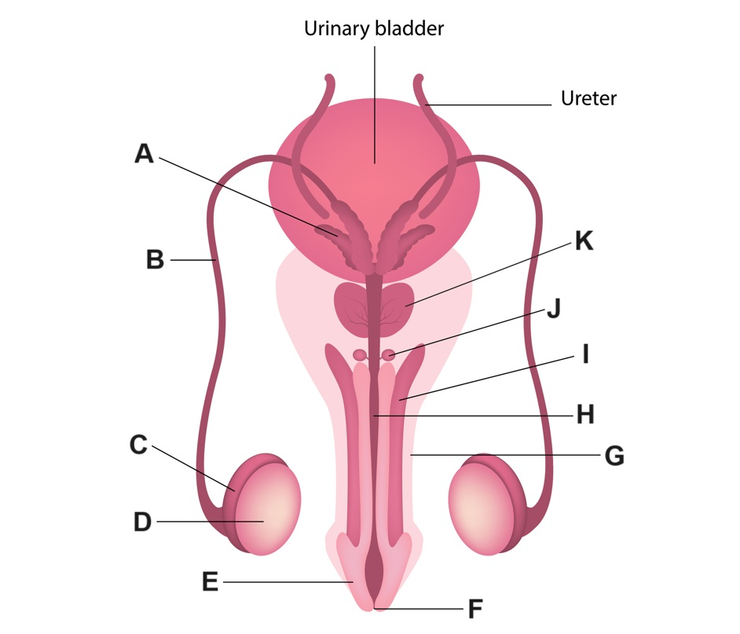

(a) Complete table below, outlining the function of the labelled parts. (3 marks)

|  |  |
| --- | --- |
| **Description** | **Marks** |
| C – to store/mature sperm | 1 |
| D – to produce sperm | 1 |
| H – to allow semen/urine to exit the body | 1 |
| **Total** | **3** |

(b) Name and explain the sterilisation method of contraception that involves making an incision to remove part of the structure labelled B. (3 marks)

|  |  |
| --- | --- |
| **Description** | **Marks** |
| Vasectomy | 1 |
| Prevents movement of sperm from testes to urethra/later structures in the male reproductive system | 1 |
| Sperm cannot exit the body/ejaculate contains no gametes – therefore no fertilisation can occur | 1 |
| **Total** | **3** |

(c) Explain, referring to the relevant labelled structures in the diagram, why a man can still produce seminal fluid even after undertaking the procedure from part (b). (4 marks)

|  |  |
| --- | --- |
| **Description** | **Marks** |
| Semen is/seminal components are produced by A/K/J/seminiferous tubules/prostate/bulbo-urethral gland | 1 |
| These structures are located after the incision has occurred in the vas deferens | 1 |
| Therefore the semen can be produced and exit the urethra | 1 |
| But there will be no sperm present as it cannot travel from testes to urethra | 1 |
| **Total** | **4** |

**Question 29 (12 marks)**

The diagram below shows the structure of DNA.

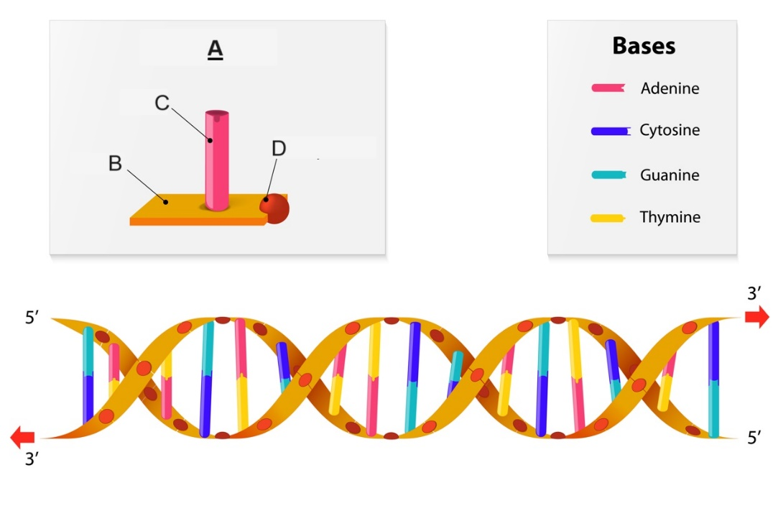

(a) State the name and describe the structure of the building blocks of DNA, labelled **A** on the diagram. (4 marks)

|  |  |
| --- | --- |
| **Description** | **Marks** |
| Nucleotide | 1 |
| Contain a phosphate molecule | 1 |
| a nitrogen base | 1 |
| and a deoxyribose sugar | 1 |
| **Total** | **4** |

(b) DNA needs to be replicated before mitosis takes place. Explain the importance of DNA replication for mitosis. (3 marks)

|  |  |
| --- | --- |
| **Description** | **Marks** |
| Mitosis produces genetically identical cells | 1 |
| DNA replication allows for chromosomes/DNA to be duplicated | 1 |
| So when they divide the same no. of chromosomes/same amount of DNA is in the daughter cells | 1 |
| **Total** | **3** |

(d) During mitosis DNA can be found in structures known as chromosomes. Describe the structure of chromosomes, and outline what occurs to chromosomes during metaphase and anaphase in mitosis. (5 marks)

|  |  |
| --- | --- |
| **Description** | **Marks** |
| Chromosomes are coiled and condensed DNA | 1 |
| Bound to proteins known as histones | 1 |
| During metaphase the chromosomes line up at the equator of the cell | 1 |
| During anaphase the chromosomes are split at the centromere | 1 |
| Each chromatid/chromosome is then pulled to the poles of the cell | 1 |
| **Total** | **5** |

**Question 35 (11 marks)**

During heavy or intensive exercise, the skeletal muscles demand high energy. Due to a limited supply of oxygen, the muscle cells resort to anaerobic respiration.

(a) Describe the process of anaerobic respiration, including the location, inputs and outputs of the process. (5 marks)

|  |  |
| --- | --- |
| **Description** | **Marks** |
| Glucose is broken down through glycolysis | 1 |
| Producing two pyruvate molecules | 1 |
| and enough energy to produce (a net yield of two) ATP molecules | 1 |
| No oxygen is required for the process | 1 |
| It occurs in the cytosol | 1 |
| **Total** | **5** |

Enzymes, such as dehydrogenase, are needed during the anaerobic respiration process. The diagram below shows the lock and key model of enzyme function.

(b) Name the structures in the diagram labelled A and B. (2 marks)

|  |  |
| --- | --- |
| **Description** | **Marks** |
| A – substrate | 1 |
| B – enzyme-substrate complex/enzyme | 1 |
| **Total** | **2** |

After intensive exercise the body may be in oxygen debt, this may trigger an increase in rate and depth of breathing.

(c) Describe and explain the process of inspiration during breathing. (4 marks)

|  |  |
| --- | --- |
| **Description** | **Marks** |
| Intercostal muscles contract and pull ribs up and out | 1 |
| Diaphragm contracts and flattens | 1 |
| This increases the volume in thoracic cavity which decreases the pressure (in comparison to the atmospheric pressure) | 1 |
| Therefore, air flows into the lungs from high to low pressure | 1 |
| **Total** | **4** |

**Question 31 (11 marks)**

The figure below shows the changes in hormones levels in females during the ovarian and menstrual cycle.

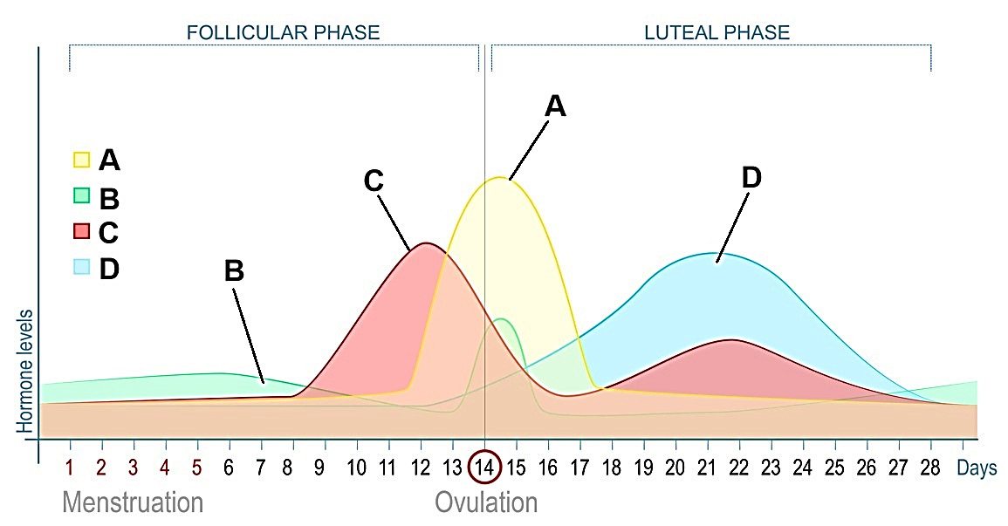

(a) Identify hormones A and C. (2 marks)

|  |  |
| --- | --- |
| **Description** | **Marks** |
| A – luteinising hormone | 1 |
| C – oestrogen | 1 |
| **Total** | **2** |

(b) Describe the role of hormone D in the ovarian and menstrual cycle. (2 marks)

|  |  |
| --- | --- |
| **Description** | **Marks** |
| Is released from the corpus luteum in the ovarian cycle | 1 |
| Maintains/thickens endometrium in the menstrual cycle | 1 |
| **Total** | **2** |

(c) State which **two** hormones from the diagram can be found in the female contraceptive pill and explain the role of **one** of these hormones used in this form of contraception.

(4 marks)

|  |  |
| --- | --- |
| **Description** | **Marks** |
| C/oestrogen | 1 |
| D/progesterone/progestin | 1 |
| Because when progesterone is high the FSH and LH are low/High progesterone decreases FSH and LH secretion/high oestrogen inhibits FSH production | 1 |
| No FSH and LH means egg can’t be released for fertilisation to occur | 1 |
| **Total** | **4** |

(d) During the process of in-vitro fertilisation (IVF), the woman needs to produce a large number of eggs to increase the likelihood of the procedure being effective. State which hormone from the diagram would be given synthetically to stimulate this process, explain your answer. (3 marks)

|  |  |
| --- | --- |
| **Description** | **Marks** |
| B/FSH | 1 |
| Because it stimulates the growth of the follicle | 1 |
| This increases the number of mature follicles (and therefore eggs) available | 1 |
| **Total** | **3** |

**Question 32** **(14 marks)**

The small intestine is the primary site for absorption of nutrients into the blood after mechanical and chemical digestion has taken place.

(a) Describe the mechanical and chemical digestion that takes place in the mouth before the food reaches the stomach. (4 marks)

|  |  |
| --- | --- |
| **Description** | **Marks** |
| Chewing/mastication occurs in the mouth | 1 |
| Breaking food into smaller pieces/increasing the surface area of the food | 1 |
| Salivary amylase is released/is contained in saliva | 1 |
| Breaking starch into disaccharides | 1 |
| **Total** | **4** |

(b) Explain the role of active transport and simple diffusion in absorption of nutrients.

(4 marks)

|  |  |
| --- | --- |
| **Description** | **Marks** |
| Active transport requires moving nutrients across the membrane against the concentration gradient | 1 |
| Which occurs for amino acids/simple sugars in the small intestine | 1 |
| Diffusion is moving materials across the membrane with the concentration gradient | 1 |
| Which includes water/fatty acids and glycerol in the small intestine | 1 |
| **Total** | **4d** |

The small intestine is comprised of different types of tissue, which suit its function in both absorption and digestion.

(c) Name and describe the structure of the two different types of tissue that would be involved in digestion and absorption in the small intestine. (4 marks)

|  |  |
| --- | --- |
| **Description** | **Marks** |
| Smooth muscle | 1 |
| Contracts to allow for segmentation/mechanical digestion | 1 |
| Epithelial tissue | 1 |
| Lines the small intestine and is made up of absorptive cells/ cells with multiple projections for absorption | 1 |
| **Total** | **4** |

**End of Section Two**

**Section Three: Extended answer 20% (35 Marks)**

**Unit 1**

**Question 33 (15 marks)**

The body’s main internal transport system is the circulatory system. It is the link between the cells inside the body, which have certain requirements and the environment outside the body, which supplies those requirements.

(a) Describe the normal flow of blood to and from the heart. (8 marks)

|  |  |
| --- | --- |
| **Description** | **Marks** |
| **Normal blood flow** | |
| Deoxygenated blood enters the right atrium | 1 |
| via the inferior and superior vena cava | 1 |
| passes through the AV valves/the tricuspid into the right ventricle | 1 |
| Passes through semilunar valve/pulmonary valve into the pulmonary artery/pulmonary trunk | 1 |
| (at the same time) oxygenated blood enters the left atrium | 1 |
| through pulmonary veins | 1 |
| Enters the left ventricle (through AV valve/mitral valve) | 1 |
| then exits through SL valve/mitral valve to the cells of the body via the aorta | 1 |
| **Total** | **8** |

(b) Some circulatory conditions can result in the need for a blood transfusion. Explain how the ABO blood grouping system influence who can donate or receive blood transfusions. (7 marks)

|  |  |
| --- | --- |
| **Description** | **Marks** |
| A antigen present means Type A | 1 |
| B antigen means Type B | 1 |
| No A or B antigen means type O | 1 |
| Can only donate to others who also have the same antigen(s) present | 1 |
| Can only receive if you already have the same antigen(s) present | 1 |
| The body will produce antibodies in response to foreign antigens | 1 |
| The antibodies will attach to erythrocytes and cause clumping of the cells/ agglutination | 1 |
| **Total** | **7** |

**Question 34 (15 marks)**

Gerald and Hecuba were catching up over a delicious dinner of steak and chips with pepper sauce, a meal rich in proteins, complex carbohydrates and fats.

(a) Describe the mechanical and chemical digestive processes that will occur throughout Gerald and Hecuba’s digestive system to breakdown their dinner. (10 marks)

|  |  |
| --- | --- |
| **Description** | **Marks** |
| Teeth/chewing breaks down food mechanically to increase surface area | 1 |
| Salivary amylase breaks down polysaccharides into disaccharides in the mouth | 1 |
| Stomach releases pepsin that breaks proteins into polypeptides | 1 |
| Three layers of muscle in stomach contract to churn the food | 1 |
| Pancreas releases amylase that further breaks down polysaccharides to disaccharides | 1 |
| also releases trypsin/protease that breaks polypeptides into smaller chains of amino acids | 1 |
| Bile from the liver/gall bladder emulsifies fats | 1 |
| Lipases from pancreas/intestine break down lipids into fatty acids and glycerol | 1 |
| Intestinal/brush border amylases break disaccharides into monosaccharides | 1 |
| Segmentation in the small intestine churns food/mixes chyme with digestive juices | 1 |
| **Total** | **10** |

(b) Enzymes in the digestive system work in specific, optimal conditions. Describe the pH in the stomach and explain the impact that pH has on enzyme function in digestion.

(5 marks)

|  |  |
| --- | --- |
| **Description** | **Marks** |
| pH is lower in the stomach/stomach has acidic pH | 1 |
| Due to presence of hydrochloric acid | 1 |
| Pepsin, enzyme released by the stomach, requires a low pH | 1 |
| Otherwise, the active site on the enzyme will not match the substrate/enzyme will not combine with substrate | 1 |
| Enzymes only work in specific, optimum pH levels | 1 |
| **Total** | **5** |

**Unit 2**

**Question 35 (20 marks)**

Gene expression refers to the phenotypic expression of genes and is achieved through protein synthesis. The expression of genes is determined by a combination of alleles which are expressed dependent on their mode of inheritance.

(a) Describe transcription and translation. (12 marks)

|  |  |
| --- | --- |
| **Description** | **Marks** |
| Transcription | |
| * DNA is transcribed to form messenger RNA * Chemical messengers/transcription factors enter the nucleus and bind to DNA at relevant gene * RNA polymerase separates the DNA molecule into two strands * RNA polymerase copies the bases on one strand of DNA to produce complementary strand of mRNA * Where there is a cytosine, a guanine will be added to mRNA * For adenine, uracil will be added * For thymine, adenine will be added * For guanine, cytosine will be added * The strand being transcribed is the template strand of DNA * Non-coding regions of mRNA called introns will then be removed * Leaving coding regions called exons * mRNA strand leaves the nucleus | 1-6 |
| **Subtotal** | **6** |
| Translation | |
| * A protein/peptide chain is produced in the cytosol/on rough endoplasmic reticulum * mRNA binds to ribosome * attaching at a start codon/sequence of three bases called a codon * The ribosome moves along, ‘reading’ the mRNA codons in order to determine the corresponding amino acids in the protein sequence * Transfer RNA molecules attached to amino acids will have a complementary anticodon * As the tRNA molecules attach their anticodon to the mRNA molecule they release the amino acid * Amino acids will bond (through peptide bonds) in the correct order to form the peptide chain (which will form the protein) * The polypeptide then detaches from the ribosome and is modified by the endoplasmic reticulum into its final protein form | 1-6 |
| **Subtotal** | **6** |
| **Total** | **12** |

(b) Describe how autosomal recessive and sex-linked recessive genetic disorders are inherited and expressed. Use examples of these disorders to support your answer.

(8 marks)

|  |  |
| --- | --- |
| **Description** | **Marks** |
| Autosomal alleles are found on autosomes/ not on sex chromosomes, while sex linked alleles are only found on the X chromosome | 1 |
| Autosomal, recessive | |
| Can be passed down by someone who is heterozygous or homozygous recessive for the genetic trait | 1 |
| Can only be expressed if the person is homozygous recessive/has two recessive alleles | 1 |
| For example, PKU is an autosomal recessive condition (could use other examples here) | 1 |
| **Subtotal** | **3** |
| Sex-linked, recessive | |
| Can be passed down if a male/female has the recessive allele on the X chromosome | 1 |
| can be expressed in females if each X chromosome has a copy of the allele | 1 |
| Can be expressed in males if they have the recessive allele/a male does not need two copies to express/male will not express with two alleles as they have only have one X chromosome | 1 |
| For example, red-green haemophilia is a sex-linked recessive condition (could use other examples here) | 1 |
| **Subtotal** | **4** |
| **Total** | **8** |

**Question 36 (20 marks)**

Germline, or germ cells, are the cells that give rise to the gametes in the ovaries and testes. These diploid cells are formed during embryonic and foetal development as a result of differentiation from unspecialised cells known as stem cells.

(a) Name and describe the three types of stem cells, based on differing levels of potency.

(8 marks)

|  |  |
| --- | --- |
| **Description** | **Marks** |
| Totipotent | 1 |
| Can potentially form any cell of the embryo | 1 |
| Including the cells of the embryonic membranes/tissues required for embryonic and foetal development | 1 |
| Pluripotent | 1 |
| Can differentiate to form any cell of the human body | 1 |
| Cannot form embryonic membranes | 1 |
| Multipotent | 1 |
| Can only differentiate into a selection of specific cell types | 1 |
| **Total** | **8** |

(b) Describe how gametes are produced through the processes of spermatogenesis and oogenesis. (12 marks)

|  |  |
| --- | --- |
| **Description** | **Marks** |
| Spermatogenesis | |
| Seminiferous tubules are lined with (immature), diploid spermatogonia | 1 |
| At puberty they spermatogonia divide by mitosis, can enlarge and form primary spermatocytes | 1 |
| Primary spermatocytes go through first meiotic division to produce secondary spermatocytes | 1 |
| Secondary spermatocytes divide again to produce haploid spermatids that mature to form spermatozoa/sperm | 1 |
| **Subtotal** | **4** |
| Oogenesis | |
| Before birth, diploid germ cells known as oogonia develop in ovaries | 1 |
| By the time of birth, oogonia have undergone mitosis and matured into primary oocytes | 1 |
| They begin the first meiotic division but stop at prophase I | 1 |
| At puberty the primary oocyte can complete first meiotic division and produce secondary oocyte and first polar body | 1 |
| Secondary oocyte is released from ovary into the fallopian tube/is ovulated | 1 |
| Secondary spermatocyte begins second meiotic division but stops at metaphase II | 1 |
| Meiosis will not complete unless cytoplasm is penetrated by sperm at the point of conception | 1 |
| This will produce an ovum and a second polar body | 1 |
| **Subtotal** | **8** |
| **Total** | **12** |

**End of questions**

**ACKNOWLEDGEMENTS**

**Question 5 – 7** Adapted from: Vectormine. (n.d) [Stages of meiosis diagram]. Retrieved from <https://www.dreamstime.com/stages-meiosis-vector-illustration-labeled-cell-division-process-scheme-explanation-genetic-aspect-interphase-image179364753>

**Questions 13 – 14** Adapted from: Watiporn (n.d.) [Carrier protein function diagram]. Retrieved from <https://www.dreamstime.com/carrier-protein-function-small-green-molecules-transport-cytoplasm-extracellular-fluid-using-plasma-membrane-image185994294>

**Question 15 – 16** Adapted from: CNX OpenStax. (2016) Retrieved from [File:Figure 38 04 04.jpg - Wikimedia Commons](https://commons.wikimedia.org/wiki/File:Figure_38_04_04.jpg)

**Question 24 – 26**  Adapted from: Sunshineconnelly (2007) Retrieved from [File:Anatomy and physiology of animals Antagonistic muscles, flexion&tension.jpg - Wikimedia Commons](https://commons.wikimedia.org/wiki/File:Anatomy_and_physiology_of_animals_Antagonistic_muscles,_flexion%26tension.jpg)

**Question 32** Adapted from: Griskeviciene, A. (n.d.) [Nephron diagram]. Retrieved from <https://www.dreamstime.com/nephron-minute-microscopic-structural-functional-unit-kidney-composed-renal-corpuscle-tubule-consists-tuft-image241569200>

**Question 33** Adapted from: Khaipet, V. (n.d.) [Male reproductive system diagram]. Retrieved from <https://www.dreamstime.com/male-reproductive-system-anatomy-male-reproductive-system-anatomy-image148692264>

**Question 34** Adapted from: Designua (n.d.) [DNA structure diagram]. Retrieved from [DNA structure stock vector. Illustration of helix, cell - 56366025 (dreamstime.com)](https://www.dreamstime.com/stock-illustration-dna-structure-nucleotide-phosphate-sugar-bases-image56366025)

**Question 35** Adapted from: Griskeviciene, A. (n.d.) [Lock and key model diagram]. Retrieved from <https://www.dreamstime.com/lock-key-model-enzymes-proteins-act-as-biological-catalysts-biocatalysts-catalysts-accelerate-chemical-reactions-lock-image241462870>

**Question 36** Adapted from: Designua (n.d.) [Menstrual cycle diagram]. Retrieved from <https://www.dreamstime.com/stock-illustration-menstrual-cycle-hormone-level-ovarian-follicular-luteal-phase-image97174422>